Northeast Karate
5th Annual Invitational Shiai
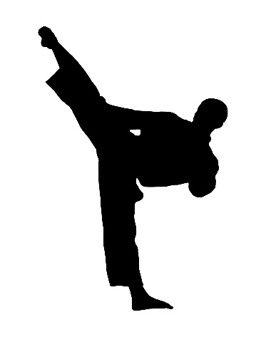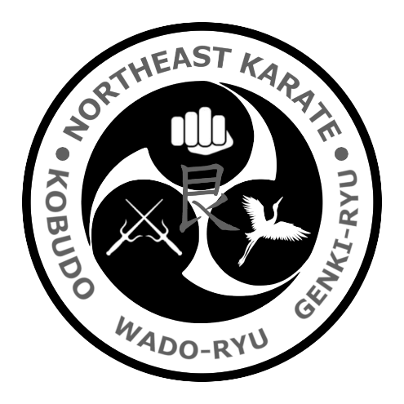
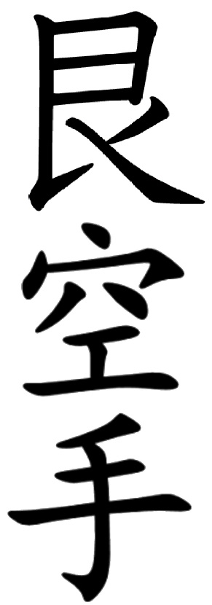 | When: Saturday, June 27, 2026  10:00am-2:30pm, Check-in at least 15min before your division start time.  Where: Huntington Park Rec. Centre,  87 Brentwood Dr.,Hamilton, ON  What: Kata, Kumite, Kobudo  Contact: Sensei Jay Misuk Northeastkarate@gmail.com (905-869-8663)
Costs
Please pay via e-transfer (northeastkarate@gmail.com) or cash.
Pre-registration (received before June 18): $45 for 1-2 events ($10 for each additional event).
At the door: $50 for 1-2 events, $10 for each additional
Spectators: $5/person (4 and under and 75+ are free!)
Notes
*** This tournament is intended to be ENTRY level ***
Kata: must be traditional forms (no music) and belt appropriate (ie. no black belt katas for kyu belt competitors) and will be scored by WKC scoring).
Kumite: full sparring kit required (helmet, gloves, boots, mouthguard); no low techniques, no back techniques, no face contact, no heavy contact. 5-point matches for Black belts, 3-point matches for Kyu belts.
Kobudo: must be traditional forms (no music), no releases
*** Separate ring available for warm up

*** Trophies for 1st,2nd & 3rd; Ribbons for 4th
Approximate Schedule (subject to change)
10:00 – Registration, bow-in, Black Belt Divisions (M/F 17-34 + 35+)
10:30 – Beginner Divisions (5-, 6-7, 8-10, 11-12, 13-14, 15-34, 35+)
11:00 – Intermediate Divisions (5-, 6-7, 8-10, 11-12, 13-14, 15-34, 35+)
12:30 – Advanced Divisions (5-, 6-7, 8-10, 11-12, 13-14, 15-34, 35+)
Advanced is Blue-Jr. Black; Intermediate is Orange-Green; Beginner is White-Yellow

Email Sensei Jay Misuk (northeastkarate@gmail.com) to register or complete your form and pass it along to your sensei to complete your registration. Please include your name, age, club, style, and which events you are interested in entering.
Please select which event(s) you are registering for.
(Beg. = White/Yellow; Int. = Orange/Green; Adv. = Blue-Jr. Black)

Kata ___ Kumite ___ Kobudo ___

Name: _____________________________________
Dojo: ______________________________________
Style: ______________________________________
Age: ________ Rank: ____________
Competing in: _______________________________

Waiver and Permission
In consideration of participating in this event held by Northeast Karate (heretofore referred to as “club”); the undersigned (or designate) does hereby for himself/herself, his/her heirs, executors, administrators, successors and assigns release and forever discharge the Promoter, Instructors, and organizers of said club and event and their servants and agents and all those in any way connected with the running and management of the same, from any and all actions, causes of actions, claims and demands for, upon or by reason of any damage, loss, or injury to person and property and death which heretofore has been or hereafter may be sustained in consequence of the undersigned participating in said club and event from this day forward.
Date: ___________________
I acknowledge that I have read the foregoing prior to signing the release and that I fully understand the same.

Signature (if under 18 years of age, parent’s or guardian’s signature required)

